

ITO 5047: Fundamentals of Artificial Intelligence

Assessment 2: Bayesian Networks

Student Name: Tristan Sim Yook Min
Student ID: 30428831

Date: 18th July 2025

Question 1: Task Environment [4+3+2 marks]

Consider the task of marathon running, and complete the following:

(a) Use a PEAS description to specify the task environment. [4 marks]

Performance Measure | - Win the Marathon or Qualify for Top 10 Positions  - Complete the Marathon in the fastest time possible  - Complete the Race without causing Accidents or Injury
Environment | - Enclosed Marathon Route ranging from 10 to 30 miles  - Outdoor Weather (Sunlight, Heat, humidity & wind)  - Varying Terrain Elevations (Hills, Walkways, Bumps)
Actuators | - Legs for running  - Mouth for drinking water to stay hydrated  - Respiratory System to provide oxygen to the body
Sensors | - Eyes to identify route and obstacles  - Ears for Environmental Noise  - Pain receptors for identifying potential injuries

(b) Specify three properties/characteristics of the environment. Explain these properties in the context of the task. [3 marks]

Partially Observable | The runners do not know the entire marathon route completely. They have no definite knowledge of the route elevations, potholes or even unforeseen potential hazards.
Stochastic | There are many unpredictable factors beyond the runner’s control like the behaviour of other runner and temperature which could be much hotter than the average which affects the runner’s hydration or even a nearly formed pothole.
Dynamic | Conditions can change like the weather’s sudden change in temperature or humidity which can wear the runner down more than usual. Even the position where the runner is at can affect how he or she can pace themselves in the race.

Question 1: Task Environment [4+3+2 marks]
(c) Determine which of the following agent types you would employ and explain why: Simple Reflex, Model-based, Goal-based, or Utility-based. [2 marks]

Agent Type | Utility-Based Agent
Justification | Based on his percept of the Marathon Environment, he/she will have to plan and strike a balance between effectively using the body’s energy reserves and race speed to win the race. The runner will have to weight many factors like elevation, hydration levels, temperature and humidity along with the safety of the other runners too. The Runner will have to adjust this marathon strategy to best maximise his chances of winning.  This ‘Utility-Driven Reasoning’ approach is why a Utility-Based Agent best represents the runner because the runner must make decision to best maximise winning the race whilst minimizing potential injury and waste of energy.

Question 2: Uninformed search [4+4 marks]
(a) Depth First Search (DFS). [4 marks]
List the nodes according to their order of expansion. Assume that rightmost nodes are expanded first. Moreover, list the nodes in the final search tree—that is, without the nodes deleted by the algorithm.

Answer:
Order of Expansion: 44 → 24 → 5 → 9 → 10 → 3
Final Path: 44 → 24 → 10 → 3

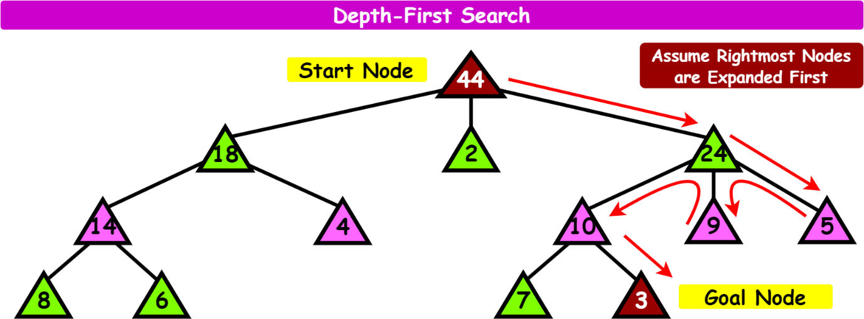

Question 2: Uninformed search [4+4 marks]
(b) Breadth First Search (BFS). [4 marks]
List the nodes according to their order of expansion. Assume that rightmost nodes are expanded first.
Answer:
Order of Expansion: 44 → 24 → 2 → 18 → 5 → 9 → 10 → 4 → 14 → 3
Final Path: 44 → 24 → 10 → 3

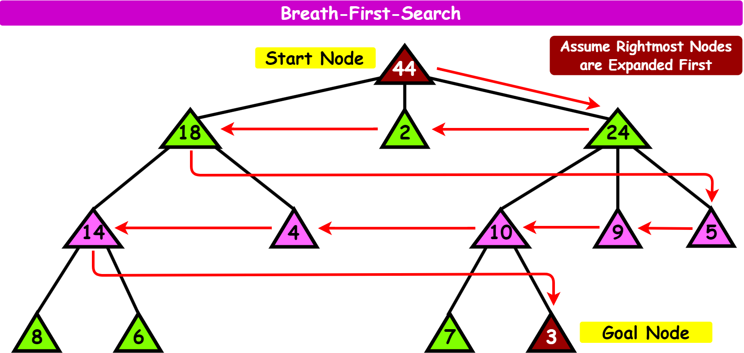

Question 3: Informed search [7+10 marks]
Consider a grid of size 3 by 3 that represents a map. In each tile of the grid, there is a letter representing a kind of terrain. There are two types of terrains in the map: A and B. Currently, a robot is at the top right corner. We use the “∗” symbol to represent the current location of the robot.
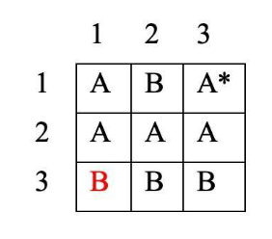
Assume that the X axis is the horizontal direction while the Y axis is the vertical direction—so the current location of the robot is (3, 1). The robot needs to do some tasks at position (1, 3), depicted in red. It takes 1 minute for the robot to move from one tile to another. However, when the robot is moving from one type of terrain to another type, it has to change its wheels before the moving, which takes two extra minutes. The robot can only move horizontally or vertically (thus, the robot cannot move diagonally).
Using the A* algorithm, suppose that we want to find a path that takes the least time to make the robot move from position (3, 1) to position (1, 3). Based on this information:
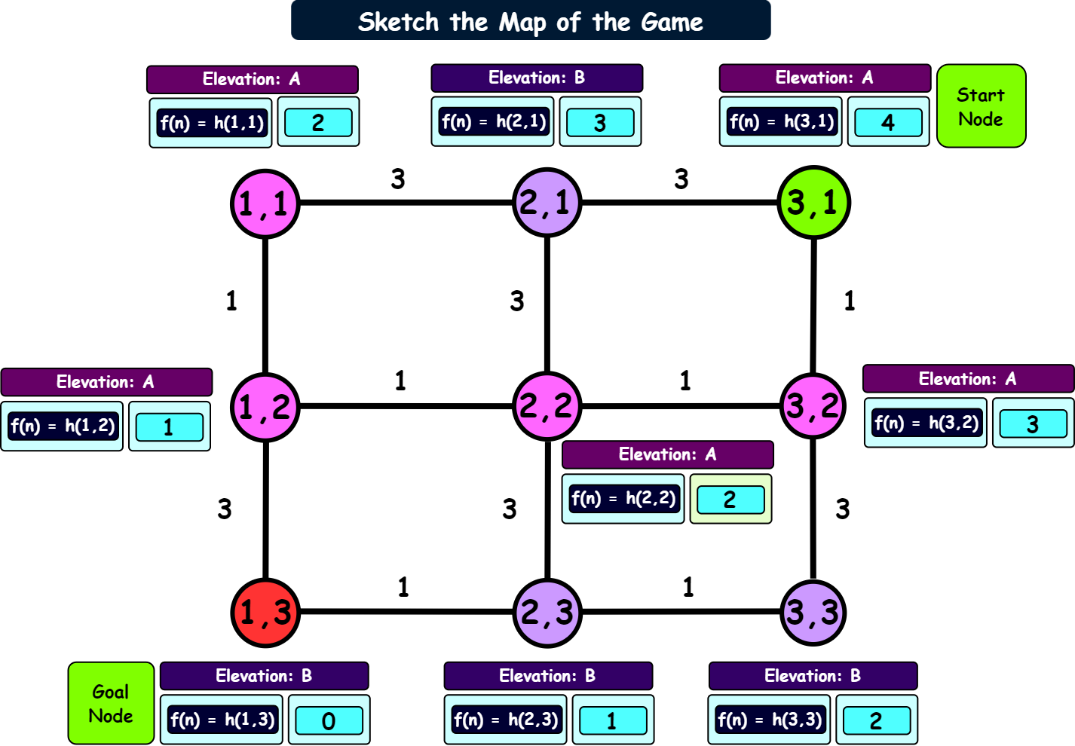
Question 3: Informed search [7+10 marks]
(a) Greedy best-first search. [7 marks] (use Left, Down, Right, Up order)

Answer:
Order of Expansion: (3,1) → (2,1) → (1,1) → (1,2) → (1,3)
Final Path: (3,1) → (2,1) → (1,1) → (1,2) → (1,3) Cost: 10 Minutes

The Manhattan Distance is a good choice for the Path Finding Robot because it matches the movement constraints of the robot. The Robot only being able to move horizontally or vertically but never diagonally. Since the map is a grid-based system of 3x3 grid, the Manhattan Distance calculates the minimum number of moves required to reach the Goal Node. Where the further the node is away from the Goal Node, the higher its Heuristic Cost. This makes it admissible for the A* Search since it never overestimates the actual cost.

Heuristic Function | Using the Manhattan Distance,  $$h\left(n\right)=\left|x_{current}-x_{goal}\right|+\left|y_{current}-y_{goal}\right|$$
Admissibility | This heuristic function is admissible because it does not overestimate the actual cost to reach the goal and ignores obstacles.

Position | Calculations | $$h\left(n\right)$$
(1,1) | $$h\left(n\right)=\left|1-1\right|+\left|1-3\right|=2$$ | 2
(2,1) | $$h\left(n\right)=\left|2-1\right|+\left|1-3\right|=3$$ | 3
(3,1) | $$h\left(n\right)=\left|3-1\right|+\left|1-3\right|=4$$ | 4
(1,2) | $$h\left(n\right)=\left|1-1\right|+\left|2-3\right|=1$$ | 1
(2,2) | $$h\left(n\right)=\left|2-1\right|+\left|2-3\right|=2$$ | 2
(3,2) | $$h\left(n\right)=\left|3-1\right|+\left|2-3\right|=3$$ | 3
(1,3) | $$h\left(n\right)=\left|1-1\right|+\left|3-3\right|=0$$ | 0
(2,3) | $$h\left(n\right)=\left|2-1\right|+\left|3-3\right|=1$$ | 1
(3,3) | $$h\left(n\right)=\left|3-1\right|+\left|3-3\right|=2$$ | 2

Question 3: Informed search [7+10 marks]

Draw the search tree generated by the algorithm using your heuristic function, indicating the values of f and h for each node, in the following box.

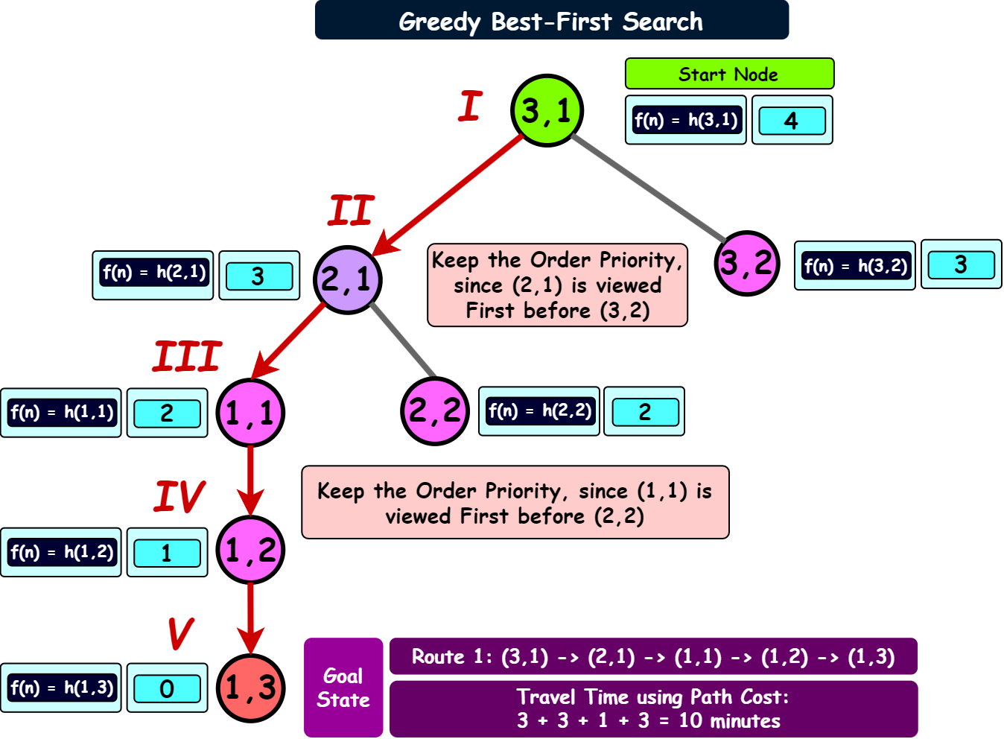

Question 3: Informed search [7+10 marks]

(b) Algorithm A∗. [10 marks] (use Left, Down, Right, Up order)

Answer: A* is produces a more Optimal Route Cost than Greedy.
Order of Expansion: (3,1) → (3,2) → (2,2) → (1,2) → (1,3)
Final Path: (3,1) → (3,2) → (2,2) → (1,2) → (1,3) Cost: 6 Minutes

Draw the tree in the following box and indicate the values of g, h and f, and use Roman numbers to indicate the order in which nodes are expanded.

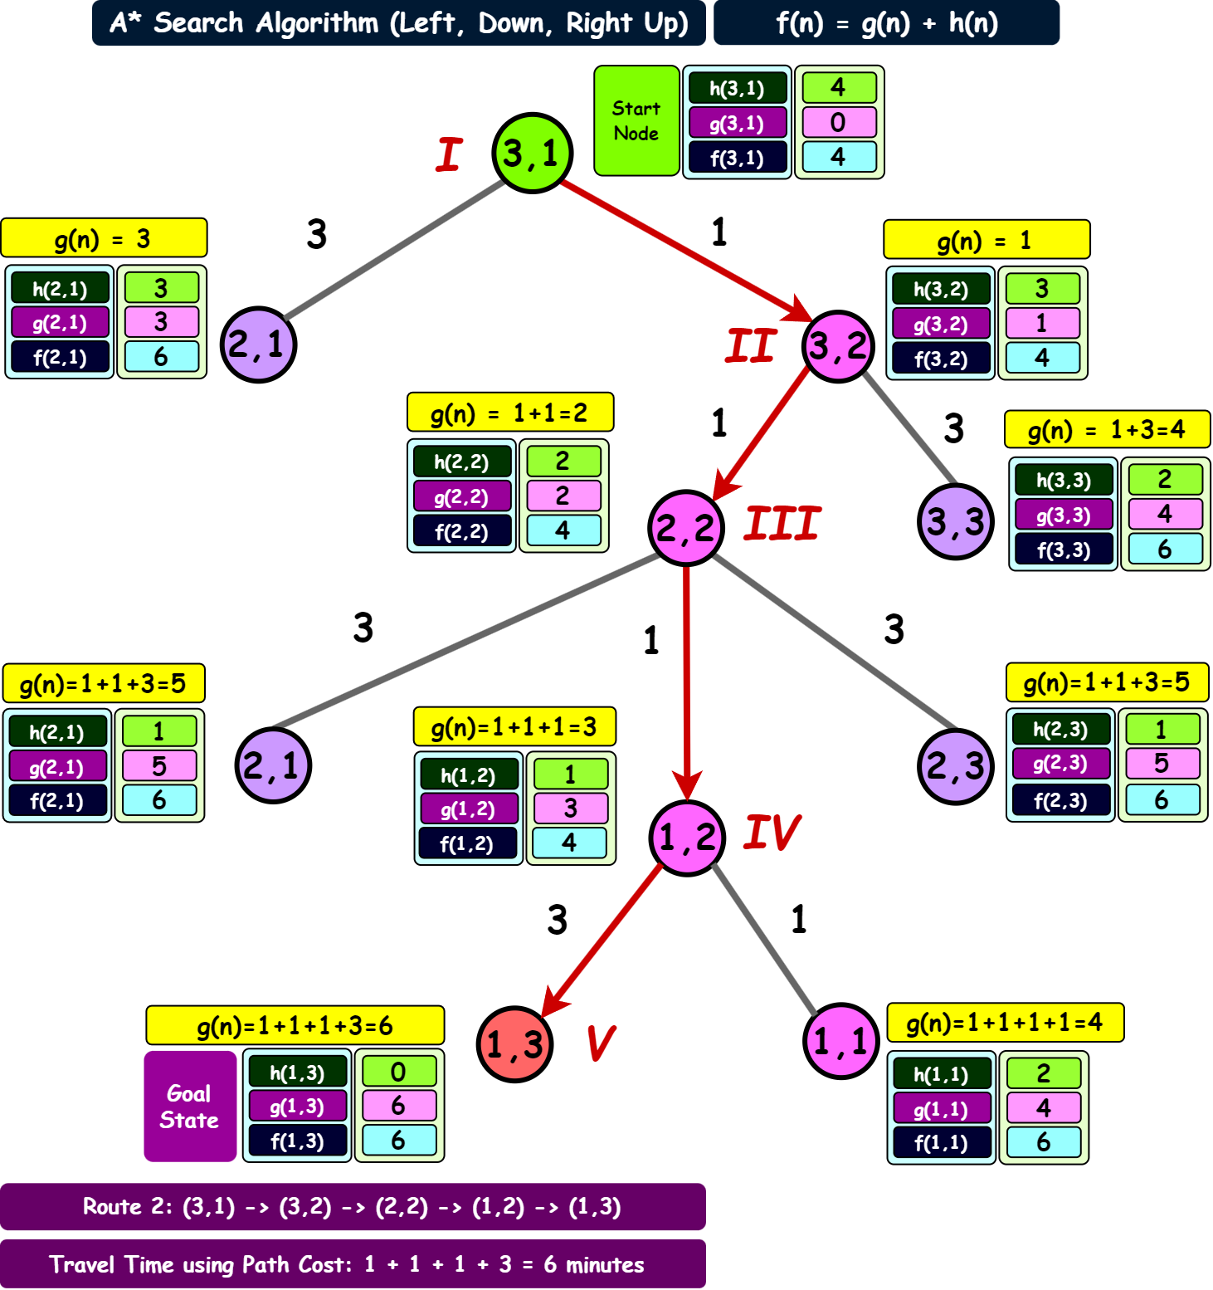
Question 3: Informed search [7+10 marks]

A* Algorithm finds an Optimal Path by using function f(n) to sum the accumulated path cost g(n) and admissible heuristic function h(n). Unlike Greedy Best-First Search which uses only the heuristics function, it can choose less optimal paths because it does not account for the path cost, leading it to choose paths that are immediately attractive but overall, may result in a less optimal path to reach the goal state.

Hence, from the previous search example, Greedy found a path to the destination node which took 10 minutes whilst the A* Algorithm found the most optimal and time cost efficient path to reach the destination with a travel cost of 6 minutes.

Question 4: Adversarial search [4+12 marks]
The figure below shows a game tree in which leaf nodes have the stated utility values. Nodes depicted with △ belong to player MAX, while nodes depicted with ▽ belong to MIN.
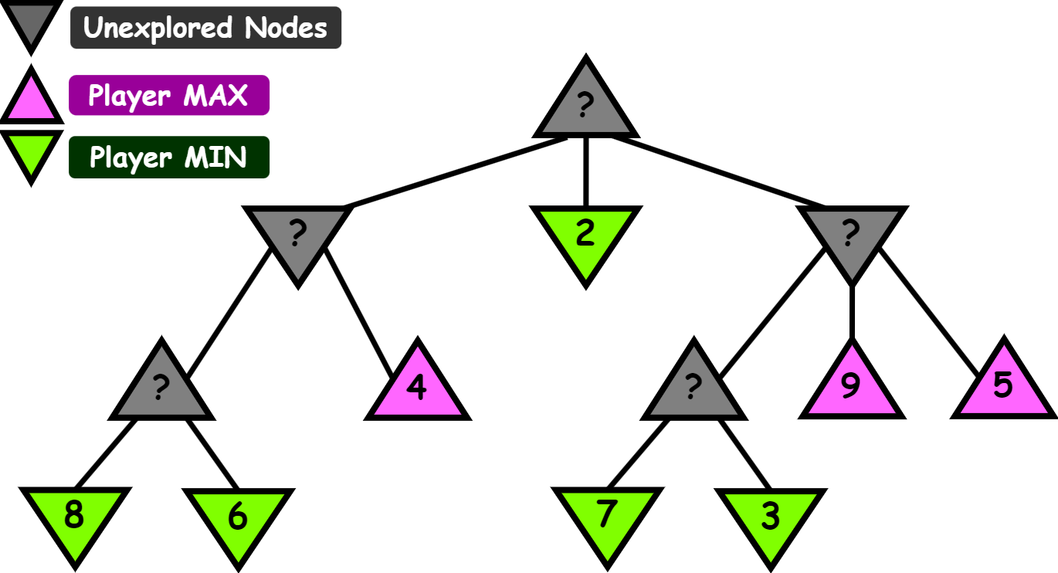
(a) Minimax algorithm. [4 marks]
Using Minimax, display the computed Minimax values for all nodes in the game tree.

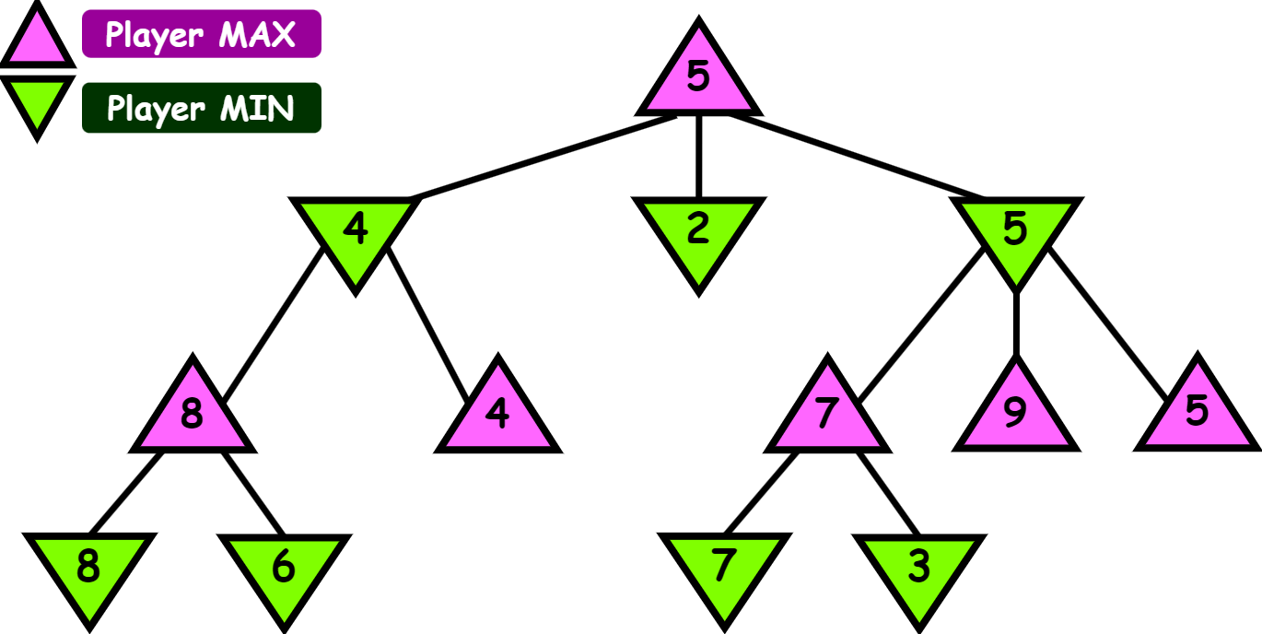

Question 4: Adversarial search [4+12 marks]
(b) Alpha-Beta pruning. [12 marks]
Perform the α−β search algorithm assuming that the rightmost nodes are expanded first. Then, cross out the branches that will be pruned by the algorithm and in each case indicate if it is an α cut-off or a β cut-off. Also, for all non-leaf nodes in the search tree generated by the α−β search algorithm, display the sequence of α or β values computed by the algorithm at that node (with leftmost values in the sequence having been computed first)

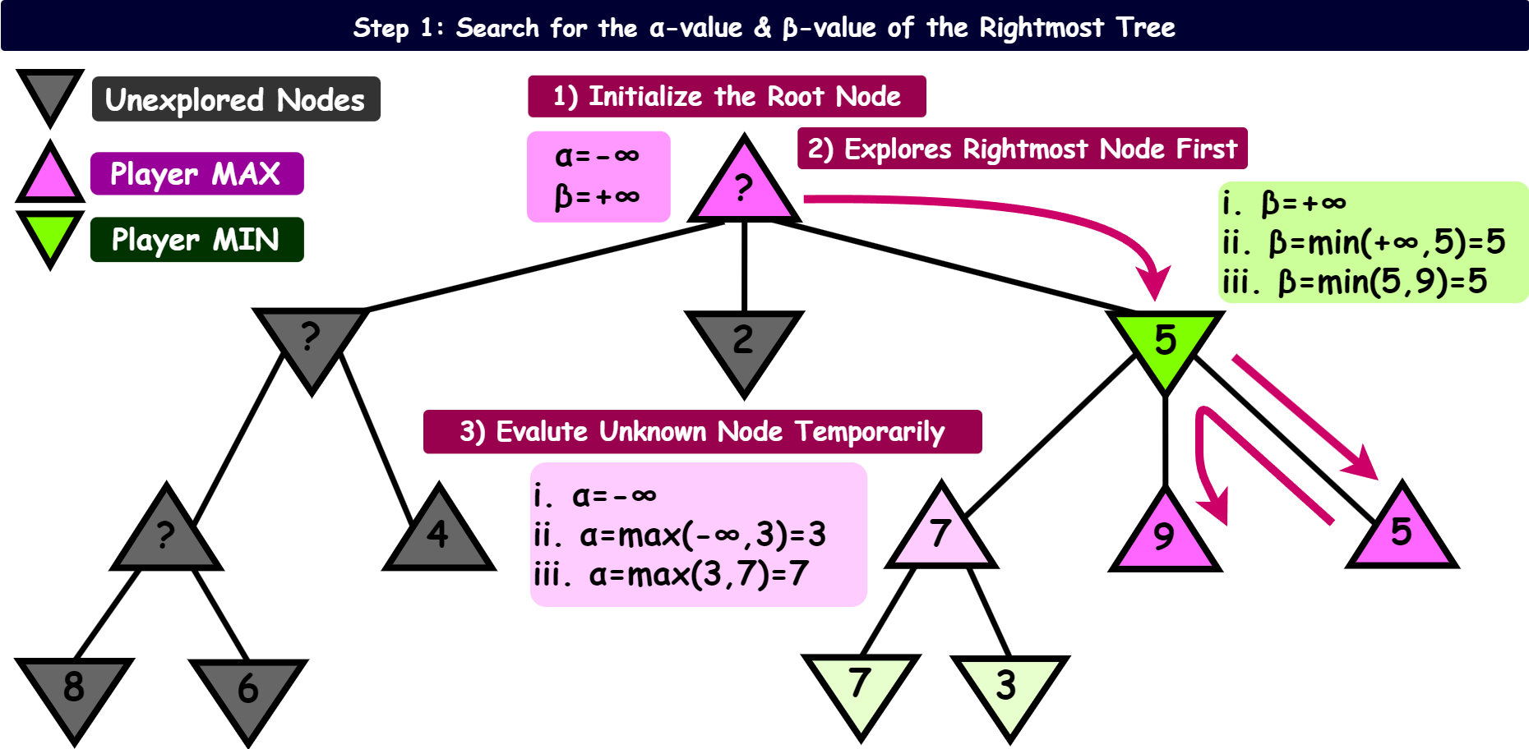

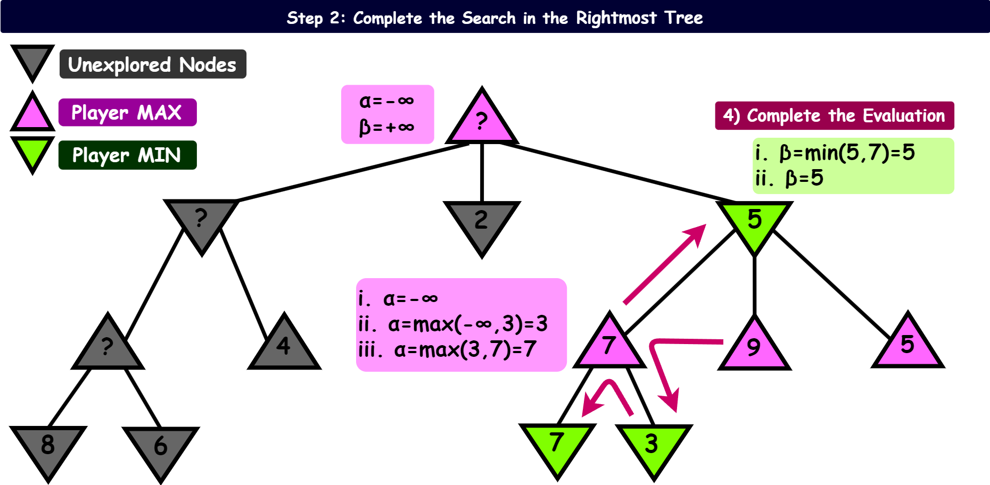

Question 4: Adversarial search [4+12 marks]

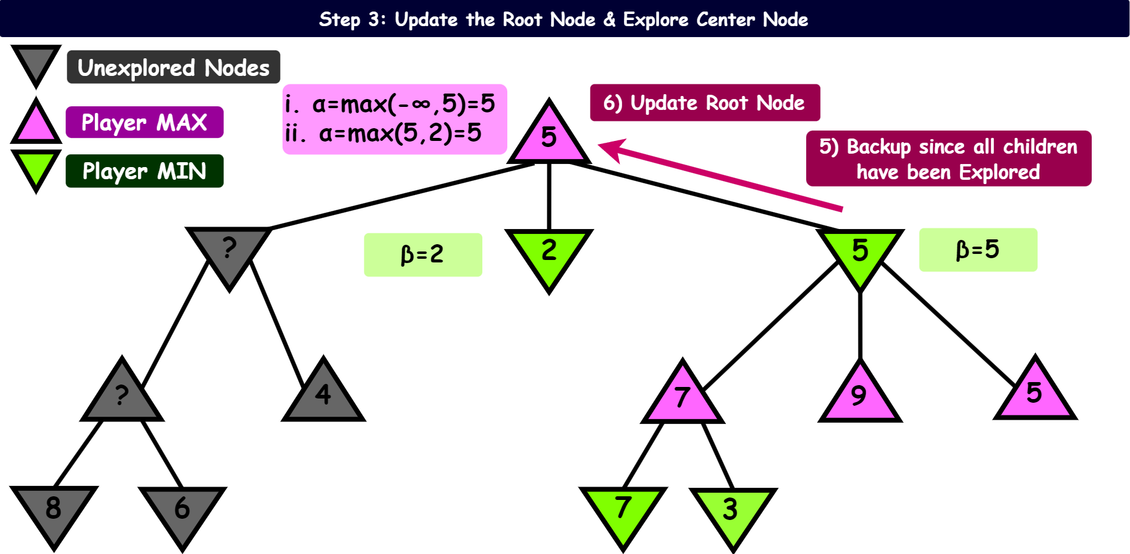

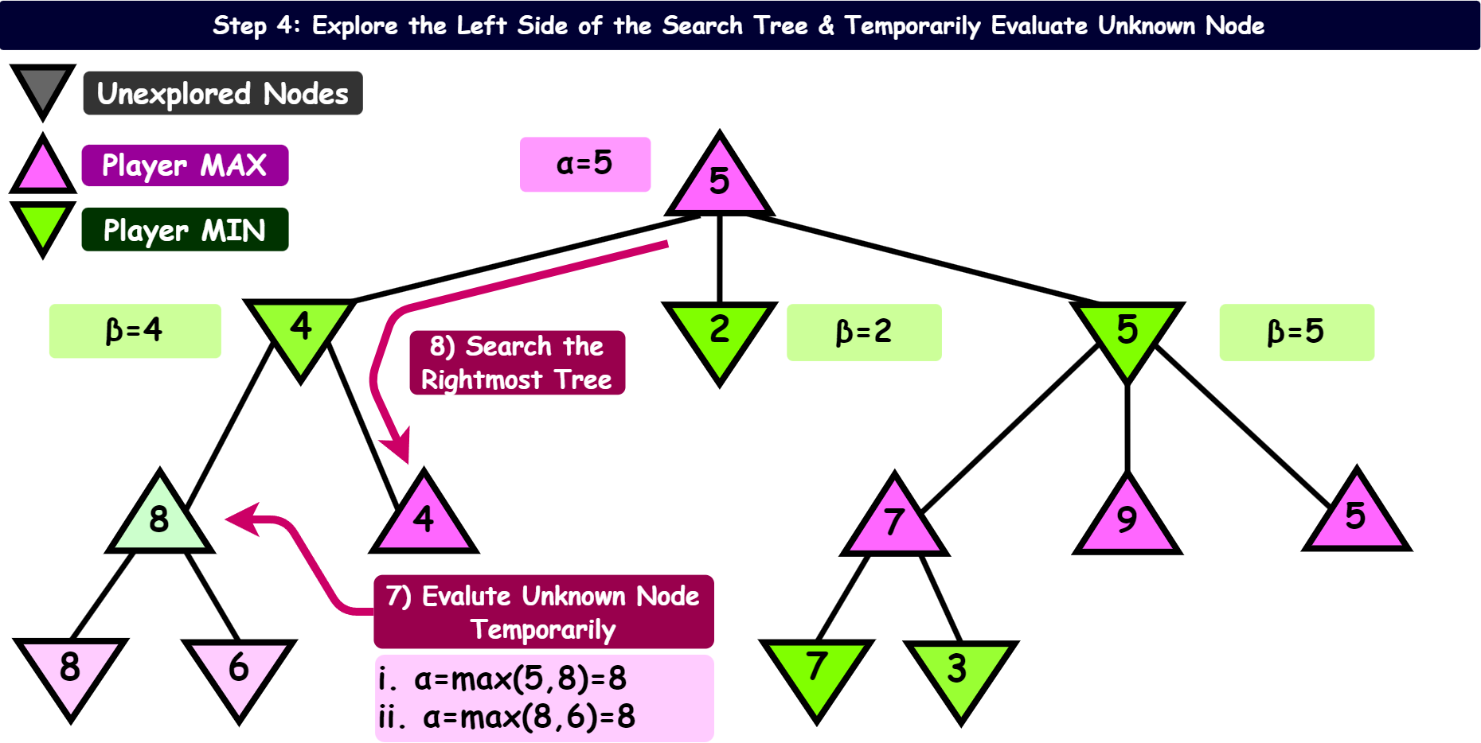

Question 4: Adversarial search [4+12 marks]

